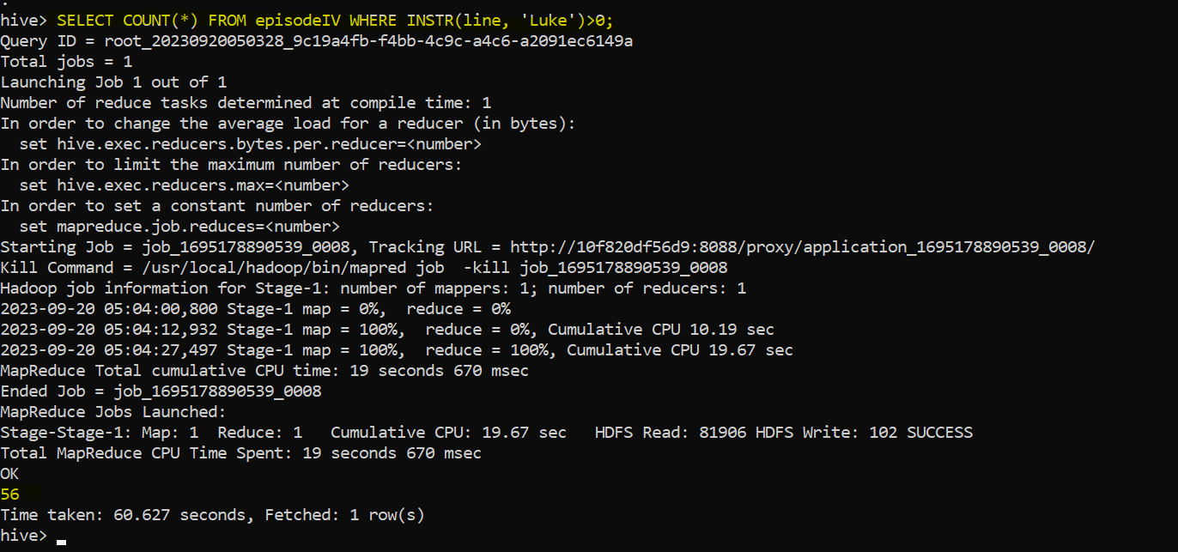

Store Results in HDFS

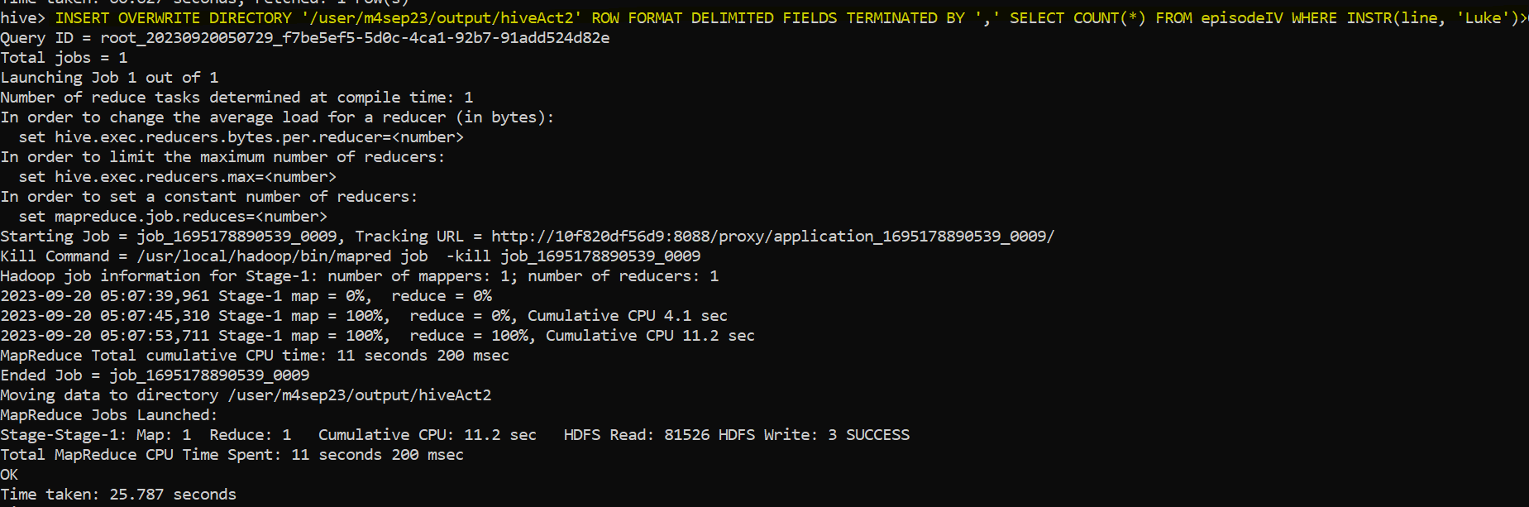

Store results on local file

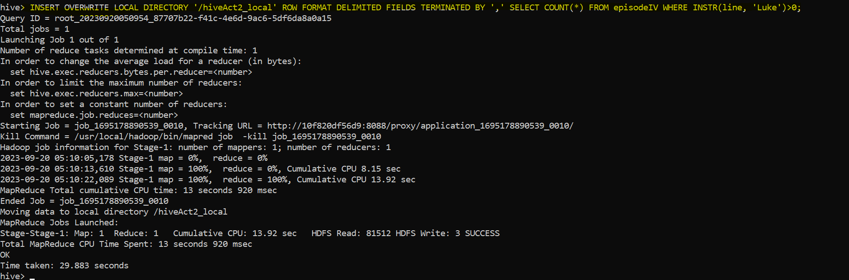

View Results  
  
